Please follow the below instructions.

1. Locate the below book**:**

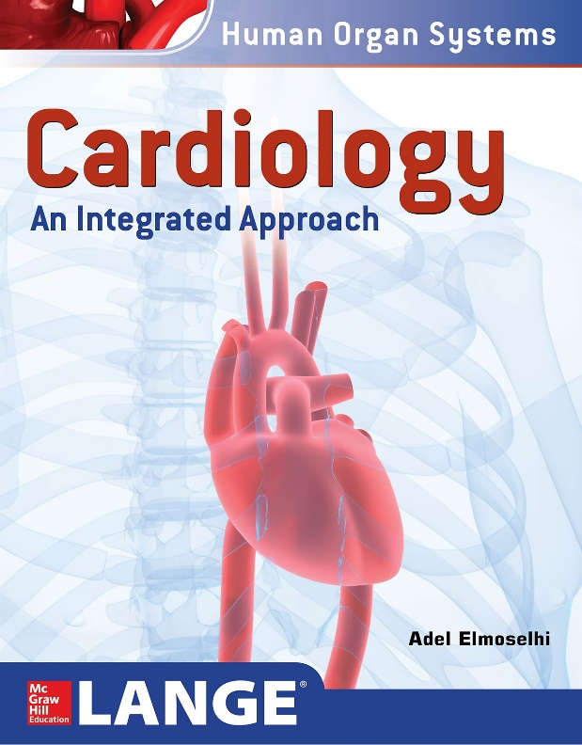

1. Fill details of the book:

|  |  |  |
| --- | --- | --- |
| Year of copyright | : |  |
| Copyright by | : |  |
| Cite the book (APA / Vancouver style | : |  |
|  |  |  |
|  |  |  |